**deUNIT – IV**

Cmputer Fundamentals

**INPUT OUTPUT ORGANIZATION**

**Peripheral Devices** :

A **peripheral** **device** is generally defined as any auxiliary **device** such as a computer mouse or keyboard that connects to and works with the computer in some way.

Following are some of the important input devices which are used in a computer:

* Keyboard
* Mouse
* Joy Stick
* Light pen
* Track Ball
* Scanner
* Graphic Tablet
* Microphone
* Magnetic Ink Card Reader (MICR)
* Optical Character Reader (OCR)
* Bar Code Reader
* Optical Mark Reader (OMR)

### Keyboard

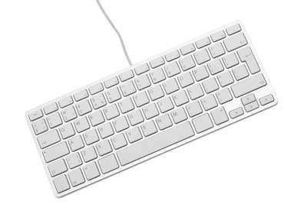Keyboard is the most common and very popular input device which helps to input data to the computer. The layout of the keyboard is like that of traditional typewriter, although there are some additional keys provided for performing additional functions.

Keyboards are of two sizes 84 keys or 101/102 keys, but now keyboards with 104 keys or 108 keys are also available for Windows and Internet.

The keys on the keyboard are as follows:

|  |  |  |
| --- | --- | --- |
| **Sr.**  **No.** | **Keys** | **Description** |
| 1 | Typing Keys | These keys include the letter keys (A-Z) and digit keys (0-  9) which generally give the same layout as that of typewriters. |
| 2 | Numeric Keypad | It is used to enter the numeric data or cursor movement. Generally, it consists of a set of 17 keys that are laid out in the same configuration used by most adding machines and calculators. |
| 3 | Function Keys | The twelve function keys are present on the keyboard which are arranged in a row at the top of the keyboard. Each function key has a unique meaning and is used for some specific purpose. |
| 4 | Control keys | These keys provide cursor and screen control. It includes four directional arrow keys. Control keys also include Home, End, Insert, Delete, Page Up, Page Down, Control(Ctrl), Alternate(Alt), Escape(Esc). |
| 5 | Special Purpose Keys | Keyboard also contains some special purpose keys such as Enter, Shift, Caps Lock, Num Lock, Space bar, Tab, and Print Screen. |

### Mouse

Mouse is the most popular pointing device. It is a very famous cursor-control device having a small palm size box with a round ball at its base, which senses the movement of the mouse and sends corresponding signals to the CPU when the mouse buttons are pressed.

Generally, it has two buttons called the left and the right button and a wheel is present between the buttons. A mouse can be used to control the position of the cursor on the screen, but it cannot be used to enter text into the computer.

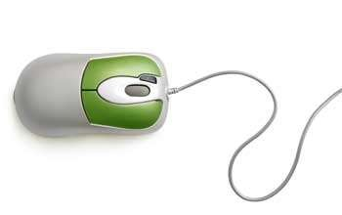

#### Advantages

* Easy to use
* Not very expensive
* Moves the cursor faster than the arrow keys of the keyboard

### Joystick

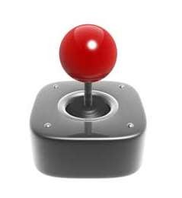Joystick is also a pointing device, which is used to move the cursor position on a monitor screen. It is a stick having a spherical ball at its both lower and upper ends. The lower spherical ball moves in a socket. The joystick can be moved in all four directions.

The function of the joystick is similar to that of a mouse. It is mainly used in Computer Aided Designing (CAD) and playing computer games.

### Light Pen

Light pen is a pointing device similar to a pen. It is used to select a displayed menu item or draw pictures on the monitor screen. It consists of a photocell and an optical system placed in a small tube.



When the tip of a light pen is moved over the monitor screen and the pen button is pressed, its photocell sensing element detects the screen location and sends the corresponding signal to the CPU.

### Track Ball

Track ball is an input device that is mostly used in notebook or laptop computer, instead of a mouse. This is a ball which is half inserted and by moving fingers on the ball, the pointer can be moved.

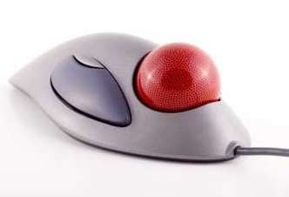

Since the whole device is not moved, a track ball requires less space than a mouse. A track ball comes in various shapes like a ball, a button, or a square.

### Scanner

Scanner is an input device, which works more like a photocopy machine. It is used when some information is available on paper and it is to be transferred to the hard disk of the computer for further manipulation.

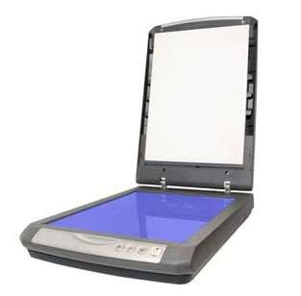

Scanner captures images from the source which are then converted into a digital form that can be stored on the disk. These images can be edited before they are printed.

### Digitizer

Digitizer is an input device which converts analog information into digital form. Digitizer can convert a signal from the television or camera into a series of numbers that could be stored in a computer. They can be used by the computer to create a picture of whatever the camera had been pointed at.

Digitizer is also known as Tablet or Graphics Tablet as it converts graphics and pictorial data into binary inputs. A graphic tablet as digitizer is used for fine works of drawing and image manipulation applications.

### Microphone

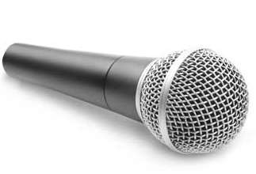Microphone is an input device to input sound that is then stored in a digital form.

The microphone is used for various applications such as adding sound to a multimedia presentation or for mixing music.

Magnetic Ink Card Reader (MICR)

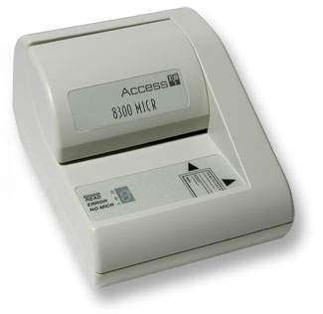MICR input device is generally used in banks as there are large number of cheques to be processed every day. The bank's code number and cheque number are printed on the cheques with a special type of ink that contains particles of magnetic material that are machine readable.

This reading process is called Magnetic Ink Character Recognition (MICR). The main advantages of MICR is that it is fast and less error prone.

### Optical Character Reader (OCR)

OCR is an input device used to read a printed text.

OCR scans the text optically, character by character, converts them into a machine readable code, and stores the text on the system memory.

### Bar Code Readers

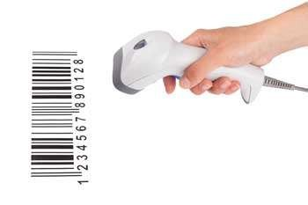Bar Code Reader is a device used for reading bar coded data (data in the form of light and dark lines). Bar coded data is generally used in labelling goods, numbering the books, etc. It may be a handheld scanner or may be embedded in a stationary scanner.

Bar Code Reader scans a bar code image, converts it into an alphanumeric value, which is then fed to the computer that the bar code reader is connected to.

### Optical Mark Reader (OMR)

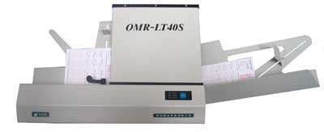OMR is a special type of optical scanner used to recognize the type of mark made by pen or pencil. It is used where one out of a few alternatives is to be selected and marked.

It is specially used for checking the answer sheets of examinations having multiple choice questions.

# Computer ces Output devices

Following are some of the important output devices used in a computer.

* Monitors
* Graphic Plotter
* Printer

## Monitors

Monitors, commonly called as **Visual Display Unit** (VDU), are the main output device of a computer. It forms images from tiny dots, called pixels that are arranged in a rectangular form. The sharpness of the image depends upon the number of pixels.

There are two kinds of viewing screen used for monitors.

* Cathode-Ray Tube (CRT)
* Flat-Panel Display

### Cathode-Ray Tube (CRT) Monitor

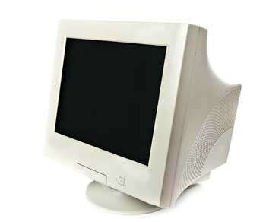The CRT display is made up of small picture elements called pixels. The smaller the pixels, the better the image clarity or resolution. It takes more than one illuminated pixel to form a whole character, such as the letter ‘e’ in the word help.

A finite number of characters can be displayed on a screen at once. The screen can be divided into a series of character boxes - fixed location on the screen where a standard character can be placed. Most screens are capable of displaying 80 characters of data horizontally and 25 lines vertically.There are some disadvantages of CRT:

* Large in Size
* High power consumption

### Flat-Panel Display Monitor

The flat-panel display refers to a class of video devices that have reduced volume, weight and power requirement in comparison to the CRT. You can hang them on walls or wear them on your wrists. Current uses of flat-panel displays include calculators, video games, monitors, laptop computer, and graphics display.

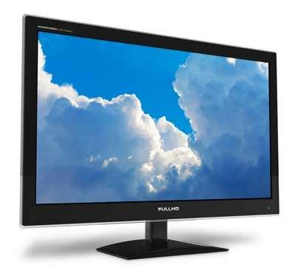

The flat-panel display is divided into two categories:

* **Emissive Displays** - Emissive displays are devices that convert electrical energy into light. For example, plasma panel and LED (Light-Emitting Diodes).
* **Non-Emissive Displays** - Non-emissive displays use optical effects to convert sunlight or light from some other source into graphics patterns. For example, LCD (Liquid-Crystal Device).

## Printers

Printer is an output device, which is used to print information on paper. There are two types of printers:

* Impact Printers
* Non-Impact Printers

### Impact Printers

Impact printers print the characters by striking them on the ribbon, which is then pressed on the paper.

Characteristics of Impact Printers are the following:

* Very low consumable costs
* Very noisy
* Useful for bulk printing due to low cost
* There is physical contact with the paper to produce an image

These printers are of two types -

* Character printers
* Line printers

### Character Printers

Character printers are the printers which print one character at a time. These are further divided into two types:

* Dot Matrix Printer (DMP)
* Daisy Wheelmn

### Dot Matrix Printer

In the market, one of the most popular printers is Dot Matrix Printer. These printers are popular because of their ease of printing and economical price. Each character printed is in the form of pattern of dots and head consists of a Matrix of Pins of size (5*7, 7*9, 9*7 or 9*9) which come out to form a character which is why it is called Dot Matrix Printer.

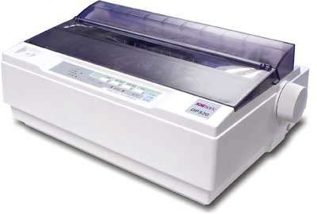

#### Advantages

* Inexpensive
* Widely Used
* Other language characters can be printed

#### Disadvantages

* Slow Speed
* Poor Quality

### Daisy Wheel

Head is lying on a wheel and pins corresponding to characters are like petals of Daisy (flower) which is why it is called Daisy Wheel Printer. These printers are generally used for word-processing in offices that require a few letters to be sent here and there with very nice quality.

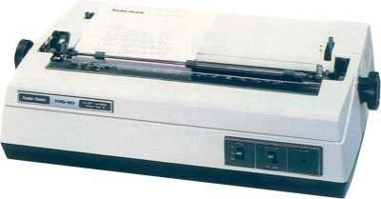

#### Advantages

* More reliable than DMP
* Better quality
* Fonts of character can be easily changed

#### Disadvantages

* Slower than DMP
* Noisy
* More expensive than DMP

### Line Printers

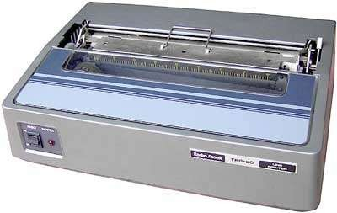Line printers are the printers which print one line at a time.

These are of two types -

* Drum Printer
* Chain Printer

### Drum Printer

This printer is like a drum in shape hence it is called drum printer. The surface of the drum is divided into a number of tracks. Total tracks are equal to the size of the paper, i.e. for a paper width of 132 characters, drum will have 132 tracks. A character set is embossed on the track. Different character sets available in the market are 48 character set, 64 and 96 characters set. One rotation of drum prints one line. Drum printers are fast in speed and can print 300 to 2000 lines per minute.

#### Advantages

* Very high speed

#### Disadvantages

* Very expensive
* Characters fonts cannot be changed

### Chain Printer

In this printer, a chain of character sets is used, hence it is called Chain Printer. A standard character set may have 48, 64, or 96 characters.

#### Advantages

* Character fonts can easily be changed.
* Different languages can be used with the same printer.

#### Disadvantages

* Noisy

### Non-impact Printers

Non-impact printers print the characters without using the ribbon. These printers print a complete page at a time, thus they are also called as Page Printers.

These printers are of two types -

* Laser Printers
* Inkjet Printers

#### Characteristics of Non-impact Printers

* Faster than impact printers
* They are not noisy
* High quality
* Supports many fonts and different character size

### Laser Printers

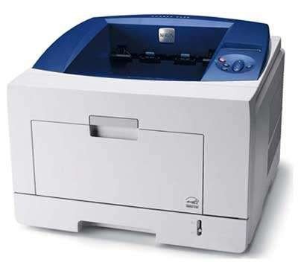These are non-impact page printers. They use laser lights to produce the dots needed to form the characters to be printed on a page.

#### Advantages

* Very high speed
* Very high quality output
* Good graphics quality
* Supports many fonts and different character size

#### Disadvantages

* Expensive
* Cannot be used to produce multiple copies of a document in a single printing

### Inkjet Printers

Inkjet printers are non-impact character printers based on a relatively new technology. They print characters by spraying small drops of ink onto paper. Inkjet printers produce high quality output with presentable features.

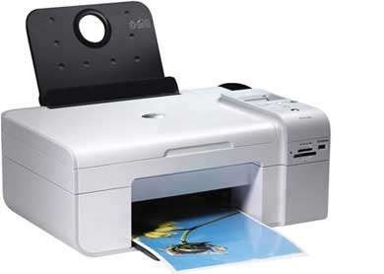

They make less noise because no hammering is done and these have many styles of printing modes available. Color printing is also possible. Some models of Inkjet printers can produce multiple copies of printing also.

#### Advantages

* High quality printing
* More reliable

#### Disadvantages

* Expensive as the cost per page is high
* Slow as compared to laser printer

## ****Input-Output Interface****

* Input-Output interface provides a method for transferring information between internal storage and external I/O devices.
* Peripherals are connected to the central processing unit with a special communication links (I/O bus).
* The I/O bus from processor is attached to all peripheral interfaces.

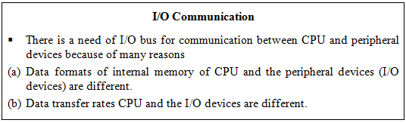

### ****Asynchronous Data Transfer****

* The two units such as CPU and I/O interface, are designed independently of each other. If the registers in the interface does not have a common clock (global clock) with the CPU registers, then the transfer between the two units is said to be asynchronous.

that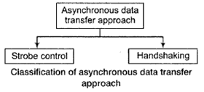

* The asynchronous data transfer requires the control signals are being transmitted between the communicating units to indicate the time at which data is being transmitted.

### ****Strobe Control****

* Strobe is a pulse signal supplied by one unit to another unit to indicate the time at which data is being transmitted.

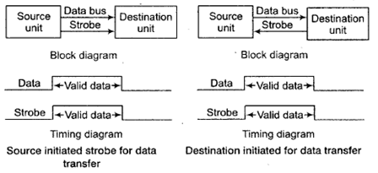

* Strobe may be activated by either the source or the destination unit.
* The strobe pulse is controlled by the clock pulses in the CPU. The data bus carries the binary information from source unit to the destination unit. In source initiated strobe for data transfer, the strobe is a single line that informs the destination unit when a valid data word is available in the bus.
* But in destination initiated for data transfer it informs the source to provide the data. Then source unit places the data on the data bus.

### ****Handshaking****

* The disadvantage of the strobe method is that the source unit has no information whether the destination unit has actually received the data item, if the source unit initiates the transfer. But if the destination unit initiates the transfer it has no way of knowing whether the source unit has actually placed the data on the bus. The handshake method solves this problem.
* The basic approach of handshaking is as follows. In handshaking method, there are two control signals unlike strobe control method. One control signal is in the same direction as the data flow in the bus from the source to the destination. This signal is used to inform the destination unit whether there are valid data in the bus. The second control signal is in the other direction from the destination to the source. It is used to inform the source whether it can accept data.

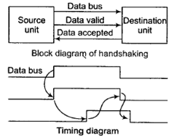

#### ****Synchronous Data Transfer****

In synchronous data transfer a global or shared clock is provided to both sender and receiver. The sender and receiver works simultaneously.

### ****Modes of Transfer****

The information from external device is stored in memory. Information transferred from the central computer into an external device via memory unit. Hence, this data transfer between the central computer and I/O devices is handled in various modes.

1. Programmed I/O
2. Interrupt- initiated I/O
3. Direct Memory Access (DMA)

**Programmed I/O:**In this mode, each data item is transferred by an instruction in the program. The CPU issues a command then waits for I/O operations to be complete.

As the CPU is faster than the I/O module, the problem with programmed I/O is that the CPU has to wait a long time for the I/O module of concern to be ready for either reception or transmission of data.

Programmed I/O basically works in these ways:

* CPU requests I/O operation
* I/O module performs operation
* I/O module sets status bits
* CPU checks status bits periodically
* I/O module does not inform CPU directly
* I/O module does not interrupt CPU
* CPU may wait or come back later

The CPU, while waiting, must repeatedly check the status of the I/O module, and this process is known as Polling. As a result, the level of the performance of the entire system is severely degraded.

**Interrupt-initiated I/O:**This mode removes the drawback of the programmed I/O mode. The CPU issues commands to the I/O module then proceeds with its normal work until interrupted by I/O device on completion of its work.

For input, the device interrupts the CPU when new data has arrived and is ready to be retrieved by the system processor. The actual actions to perform depend on whether the device uses I/O ports, memory mapping.

For output, the device delivers an interrupt either when it is ready to accept new data or to acknowledge a successful data transfer. Memory-mapped and DMA-capable devices usually generate interrupts to tell the system they are done with the buffer.

Although Interrupt relieves the CPU of having to wait for the devices, but it is still inefficient in data transfer of large amount because the CPU has to transfer the data word by word between I/O module and memory.

Below are the basic operations of Interrupt:

* CPU issues read command
* I/O module gets data from peripheral whilst CPU does other work
* I/O module interrupts CPU
* CPU requests data
* I/O module transfers data

### ****Direct Memory Access (DMA)****

Direct Memory Access (DMA) means CPU grants I/O module authority to read from or write to memory without involvement. DMA module controls exchange of data between main memory and the I/O device. Because of DMA device can transfer data directly to and from memory, rather than using the CPU as an intermediary, and can thus relieve congestion on the bus. CPU is only involved at the beginning and end of the transfer and interrupted only after entire block has been transferred.

DMA is efficient for moving large amounts of data between I/O devices and main memory. It is considered efficient because it removes the CPU from being responsible for transferring data. DMA instructs the device controller to move data between the devices and main memory.

The CPU initiates the transfer by supplying the interface with the starting address and the number of words needed to be transferred and then proceeds to execute other tasks. When the transfer is made, the DMA requests memory cycles through the memory bus. When the request is granted by the memory controller, the DMA transfers the data directly into memory.

The Bus Request (BR) input is used by the DMA controller to request the CPU to get the control of buses. When this input is active, the CPU terminates the execution of the current instruction and places the address bus and the data bus. The CPU activates the Bus Grant (BG) output to inform the external DMA that the buses are available. The DMA now takes the control of the buses to conduct the memory transfer. When DMA terminates the transfer, it disables the bus request line. The CPU disables the bus grant, takes the control of the buses.

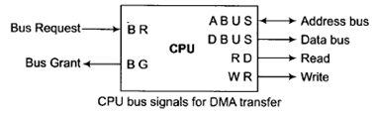

Hardware design is complicated because the DMA controller must be integrated into the system, and the system must allow the DMA controller to be a bus master. Cycle stealing may also be necessary to allow the CPU and DMA controller to share use of the memory bus.

During a block input byte transfer, the following sequence occurs as the data byte is sent from the interface to the memory:

* The interface sends the DMA controller a request for DMA service.
* A Bus request is made to the HOLD pin (active High) on processor and the controller gains control of the bus.
* A Bus grant is returned to the DMA controller from the Hold Acknowledge (HLDA) pin (active High) on the processor.
* The DMA controller places contents of the address register onto the address bus.
* The controller sends the interface a DMA acknowledgment, which tells the interface to put data on the data bus. (For an output it signals the interface to latch the next data placed on the bus.)
* The data byte is transferred to the memory location indicated by the address bus.
* The interface latches the data.
* The Bus request is dropped, the HOLD pin goes Low, and the controller relinquishes the bus.
* The Bus grant from the processor is dropped and the HLDA pin goes Low.
* The address register is incremented by 1.
* The byte count is decremented by 1.
* If the byte count is non-zero, return to step 1, otherwise stop.
* **DMA Data Transfer**
* 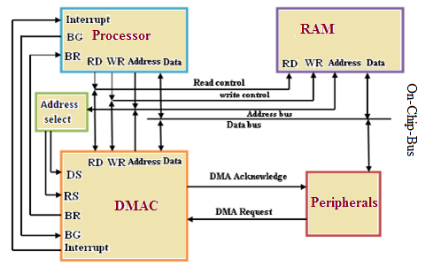

**Types of Data transfers:**The DMA Controller has several options available for the transfer of data. They are:

1. **Cycle Steal**: A read or write signal is generated by the DMAC, and the I/O device either generates or latches the data. The DMAC effectively steals cycles from the processor in order to transfer the byte, so single byte transfer is also known as cycle stealing.
2. **Burst Transfer**: To achieve block transfers, some DMAC's incorporate an automatic sequencing of the value presented on the address bus. A register is used as a byte count, being decremented for each byte transfer, and upon the byte count reaching zero, the DMAC will release the bus. When the DMAC operates in burst mode, the CPU is halted for the duration of the data transfer.
3. **Hidden DMA**: It is possible to perform hidden DMA, which is transparent to the normal operation of the CPU. In other words, the bus is grabbed by the DMAC when the processor is not using it. The DMAC monitors the execution of the processor, and when it recognises the processor executing an instruction which has sufficient empty clock cycles to perform a byte transfer, it waits till the processor is decoding the op code, then grabs the bus during this time. The processor is not slowed down, but continues processing normally. Naturally, the data transfer by the DMAC must be completed before the processor starts.

## Input/Output Processor

An input-output processor (IOP) is a processor with direct memory access capability. In this, the computer system is divided into a memory unit and number of processors. Each IOP controls and manage the input-output tasks. The IOP is similar to CPU except that it handles only the details of I/O processing. The IOP can fetch and execute its own instructions. These IOP instructions are designed to manage I/O transfers only.

### Block Diagram Of IOP

Below is a block diagram of a computer along with various I/O Processors. The memory unit occupies the central position and can communicate with each processor. The CPU processes the data required for solving the computational tasks. The IOP provides a path for transfer of data between peripherals and memory. The CPU assigns the task of initiating the I/O program. The IOP operates independent from CPU and transfer data between peripherals and memory.

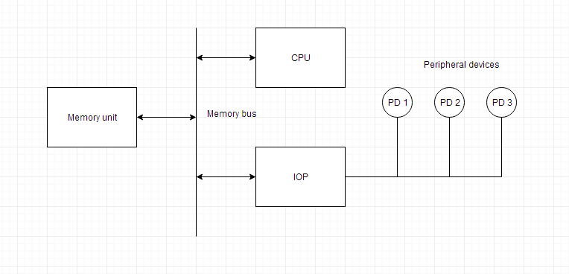

The communication between the IOP and the devices is similar to the program control method of transfer. And the communication with the memory is similar to the direct memory access method.

In large scale computers, each processor is independent of other processors and any processor can initiate the operation.

The CPU can act as master and the IOP act as slave processor. The CPU assigns the task of initiating operations but it is the IOP, who executes the instructions, and not the CPU. CPU instructions provide operations to start an I/O transfer. The IOP asks for CPU through interrupt.

Instructions that are read from memory by an IOP are also called *commands* to distinguish them from instructions that are read by CPU. Commands are prepared by programmers and are stored in memory. Command words make the program for IOP. CPU informs the IOP where to find the commands in memory.